Presentation Notes

Private Spaces and Spacialization – Points to Present 1

Spatialization 1

Main Conversation Space 1

Key Points 1

Private Spaces 1

Key Points: 1

Demonstration Flow 1

Features Designed but not yet Implemented: 1

Private Spaces and Spacialization – Points to Present

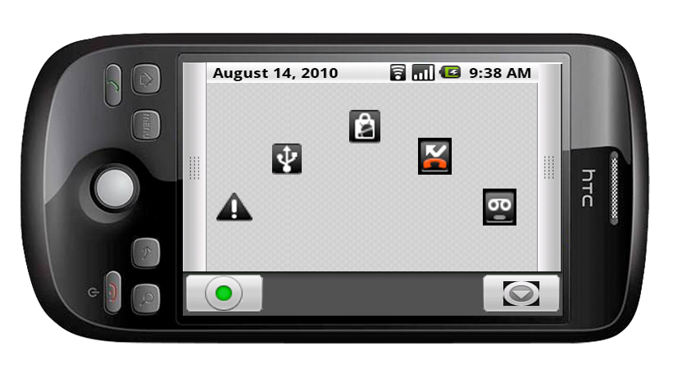

Spatialization
Private spaces and Spatialization are the key differences between our program and other VOIP solutions currently available. Private spaces will allow users to hold instanced private chats separately yet simultaneously with the main chat. Spatialization will give us a realistic 3d audio environment that will make conversations seem more natural.

Main Conversation Space
This mockup is our current representation of the main conversation space. For the purposes of the demonstration, we may limit it specifically to only a few icons (2-3). Icons in the main space reflect the position of icons in private spaces as well. What changes to the icons is made in one private space or main will reflect upon the others.
Icons currently set themselves in preset locations (for audio calculation ease). For the purposes of the demonstration we may allow real time sliding to change the audio feed, though I don’t really know how feasible this will be with the acoustics in the room the presentation will be taking place in.
For the presentation we will most likely have a prerecorded conversation which we will synch to a video.

Key Points
- Display the main conversation room
- Show the ability to move icons around that will affect the audio stream in real time
- Show how to link into private spaces
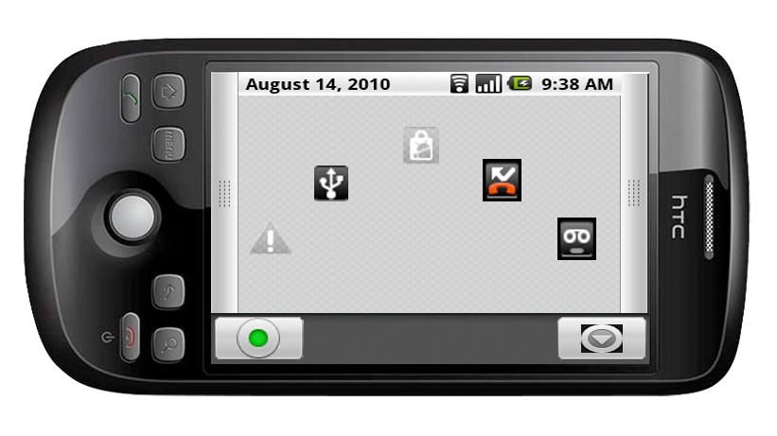

Private Spaces
Icons remain solid/dark colored if the icon is associated with a user currently inside the private space. Icons will grey/fade out, and the audio input from those users will be muffled to indicate that they are no longer in the private space.
Creating a private space will be simple. There are two main options, one can either create new spaces from an option available in Menu, or tap and drag icons from zoom into an empty private space. Adding users to a private space will bring up an invitation to join a private space, which the receiver can either accept or reject.
For the prerecorded presentation, the main conversation will likely be a lecture of some sorts—perhaps a conversation involving Bailey, Makoto, Jason. For the private space the lecture will be muffled, with Jason and Makoto talking about various subjects instead.

Key Points:
- Display Private Space
- Demonstrate how you can continue to spatialize within a private space.
- Demonstrate how the main conversation is muffled in favor of the conversation happening in the private space

Demonstration Flow
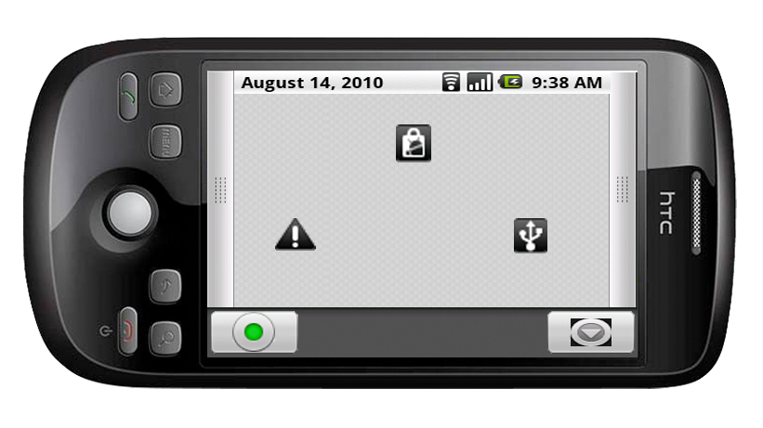
1. Make note of the three different icons and then play a short audio clip for each of the users. Clearly indicating their different locations through spatialization.
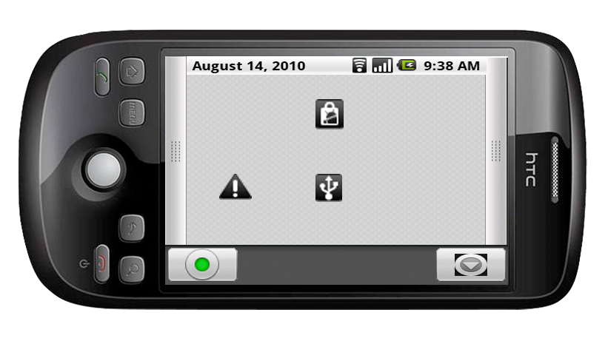
2. Move the icons around and demonstrate how moving the icons affects the sound. We will want to make extreme movements so that the audio change is extremely obvious.
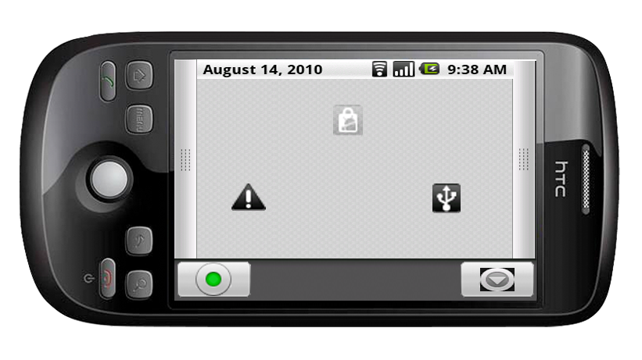
3. Create a private space. Demonstrate how both icons on the bottom still broadcast clearly, while the top icon is now out of the private space and its sound is muffled.
4. Repeat dragging in private spaces to show that the functionality exists in the private space, and reflects upon the main.

Features Designed but not yet Implemented:
1. User Info’s from clicking their icons – WIP
2. Zoomed out main view – Not presenting
3. Multiple Private Spaces – Not presenting
4. Text based chat area – Unsure if presenting

